The Engineering Design Process
Day 15: Lesson Quiz
Choose the letter of the best answer.

1. Which of the following questions can be answered through investigation using a prototype?
A. What is the migration pattern of salmon?
B. How is the salmon population in the Atlantic Ocean changing?
C. How can submarines incorporate the hydrodynamic properties of salmon?
D. What is the difference in Omega 3 fatty acids in farm-raised versus wild-caught salmon?
2. An endoscope is a probe used by doctors. An endoscope includes a camera that transmits images through narrow, flexible tubing.
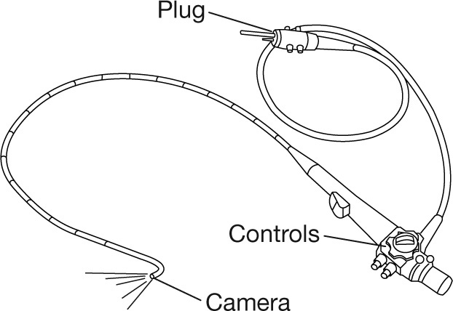
How might endoscopes help doctors to diagnose and treat patients?
A. Endoscopes allow doctors to take tissue samples.
B. Endoscopes allow doctors to measure the mass of organs.
C. Endoscopes allow doctors to see inside organs and body cavities.
D. Endoscopes allow doctors to transplant organs without making incisions.
3. How are prototypes used in the engineering design process?
A. Prototypes are lists of needs to be addressed.
B. Prototypes are the final products sold to consumers.
C. Prototypes are models that can be tested for efficiency.
D. Prototypes are tables of data that can be manipulated and analyzed.
4. Carbon monoxide is a gas that kills over
150 people in the United States each year.
A company is trying to design carbon monoxide detectors that registers carbon monoxide at levels of 5 ppm. They collected the following data while testing their carbon monoxide detectors.
Trial | Carbon monoxide level when alarm sounded (ppm)
1 | 3
2 | 74
3 | 4
After trial 2, one engineer decides that the detector is a failure. Why might another engineer disagree?
A. The data might be the result of a measurement error.
B. A carbon monoxide level of 74 ppm is still within acceptable limits.
C. Data that falls outside the data range by more than 10% should be discarded.
D. When some data follow a clear pattern, other data points can be thrown out.
5. Which of the following is not considered a type of technology?
A. an idea C. a product
B. a process D. a system

